STABILITY DATA ON STELBAT TABLETS, 20 MG

Details of the batches tested
Full details of the batches under examination are given in Table 1.
The batches of product were manufactured using the proposed commercial composition and manufacturing process.
The product was packaged in 100 cc HDPE bottles, containing 2 g desiccant. This pack is of identical composition and volume to that proposed for the commercial product.
Table 1 Details of Stability Batches of Stelbat Tablets, 20 mg
Product Strength | 20 mg | 20 mg | 20 mg
Stability Protocol Number | ABC1234 | ABC1234 | ABC1234
Drug Product Batch Number | 33445 | 33446 | 33447
Input Drug Substance Batch Number | CAT1 | CAT2 | CAT3
Site of Drug Substance Manufacture | AAA Molybdenum Products, Inc. | AAA Molybdenum Products, Inc. | AAA Molybdenum Products, Inc.
Batch Size (Tablets) | 100,100 | 100,050 | 100,125
Scale | Production | Production | Production
Site of Manufacture | AAA Pharmaceutical, Inc., Lumberton | AAA Pharmaceutical, Inc., Lumberton | AAA Pharmaceutical, Inc., Lumberton
Date of Manufacture | June, 2020 | June 2020 | July 2020
Site of Packaging | MySite | MySite | MySite
Date of Packaging | August, 2020 | August, 2020 | August, 2020
Pack | 100 cc HDPE Bottle  2 g desiccant | 100 cc HDPE Bottle  2 g desiccant | 100 cc HDPE Bottle  2 g desiccant
Date Stability Started | December, 2020 | December, 2020 | December, 2020
Data Presented (Months) | 18 | 18 | 18

Stability test protocols
The stability test protocol for accelerated and long-term storage of Stelbat Tablets, 20 mg is given in Table 2.
Table 2 Stability Test Protocol for Long-term and Accelerated Storage of Stelbat Tablets, 20 mg
Storage Test Type | Storage Condition | Storage Time (Months)
Storage Test Type | Storage Condition | Initial | 3 | 6 | 9 | 12 | 18 | 24 | 36
Long-term | 25°C/60% RH | XYZ | X | X | X | XY | XY | XY | (XY)
Accelerated | 40°C/75% RH | XYZ | X | X | − | − | − | − | −
Notes:
RH Relative Humidity.
( ) Denotes optional testing.
− Denotes testing not scheduled at these time points.

Key to Tests:
X Indicates that the following tests will be performed:
Description
Assay
Degradation Products
Dissolution
Water Content

Y Indicates that the following tests will be performed:
Microbiological Quality

Z Indicates that the following tests will be performed:
Identification
Uniformity of dosage units (by weight)

Results and discussion
Results are available following storage for up to 18 months at 25°C/60% RH and 6 months at 40°C/75% RH. The stability data are presented in Section 4.

Description
No significant change in description was observed for Stelbat Tablets 20 mg after storage at 25°C/60% RH up to 18 months and 40°C/75%RH up to 6 months. All results complied with the proposed specification.

Identification
The test for identification was only conducted at initial time point, because this parameter is not required by the protocol as considered not stability relevant. The results comply with the proposed specification.

Assay by HPLC
A decrease in API content is observed for Stelbat Tablets 20 mg after storage at 25°C/60% RH up to 18 months (see Figure 1), but results remain within the proposed specification.
An out of specification result was observed at the 12 month time point for batch 33446 stored at 25°C/65% RH. An associated investigation did not find a root cause; however, the data at 18 months is within the proposed specification, therefore this is not indicative of a stability trend.

Degradation Products
Significant changes were observed for Impurity 1, Impurity 2, Impurity 3 and Total Degradation Impurities for Stelbat Tablets 20 mg after storage at 25°C/60% RH up to 18 months and 40°C/75%RH up to 6 months. An increase in these impurities was observed which is related to the increase water content observed as discussed in P5.4 Justification of Specification.
All results complied with the proposed specification.

Dissolution
No significant change in dissolution was observed for Stelbat Tablets 20 mg after storage at 25°C/60% RH up to 18 months and 40°C/75%RH up to 6 months. All results complied with the proposed specification.

Uniformity of dosage units
The test for uniformity of dosage units (by weight) was only conducted at initial time point, because this parameter is not required by the protocol as considered not stability relevant. The results comply with the proposed specification.

Microbiological quality
Microbiological quality is tested annual, and also at the 18 month timepoint. The results comply with the proposed specification.

Water Content
An increase in water content is observed for Stelbat Tablets 20 mg after storage at 25°C/60% RH up to 18 months (see Figure 2), but results remain within the proposed specification.

Conclusion
All the results, with exception of the assay content result at the 12 month time point for Batch 33446 stored at 25°C/65% RH, for Stelbat Tablets 20 mg are within the proposed specification.
Figure 1 Effect of Storage at Long-term Storage Condition/Accelerated Storage Condition on Assay Content (% Label Claim) for Stelbat Tablets, 20 mg
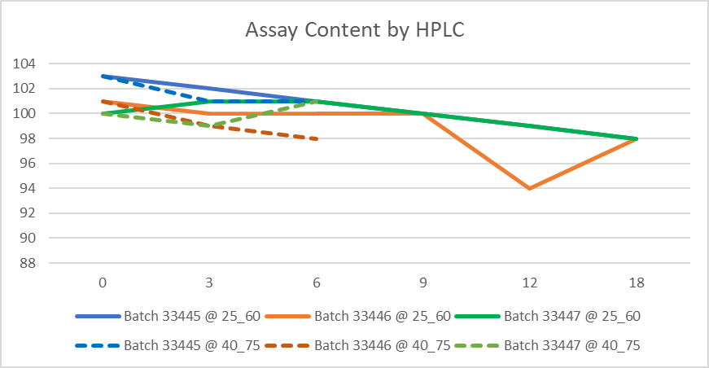
Key:
25_60 = 25°C/60% RH.
40_75 = 40°C/75% RH.

Figure 2 Effect of Storage at Long-term Storage Condition/Accelerated Storage Condition on Water Content (% w/w) for Stelbat Tablets, 20 mg
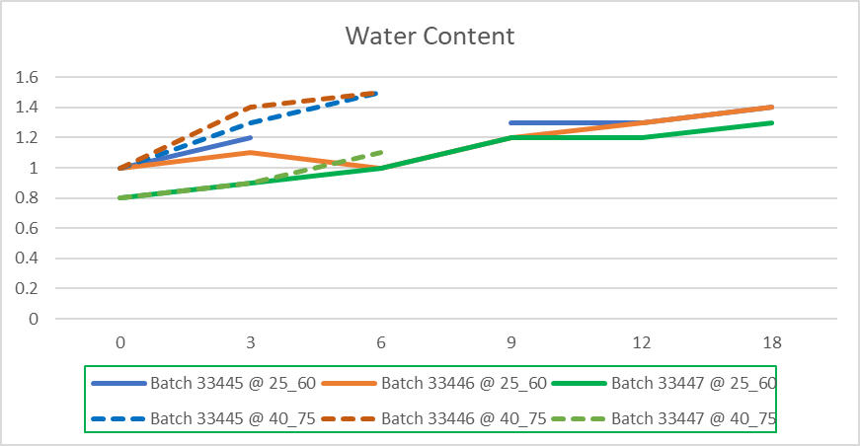
Key:
25_60 = 25°C/60% RH.
40_75 = 40°C/75% RH.

TABULATED Stability Data for Stelbat Tablets, 20 mg
Table 3 Stability Data for Stelbat Tablets, 20 mg
Protocol Number: | ABC1234 |  |  |  | Batch Number: |  | 33445 |  |  |  | Testing Ongoing
Storage Condition |  | Time  (Months) | Description | Assay Content by HPLC  (% label claim) (Mean) |  | Degradation Products by HPLC (% w/w)
 |  |  |  |  |  | Impurity 1 |  | Impurity 2 | Impurity 3 | Any Unspecified Degradation Impurity |  | Total Degradation Impurities
Specification |  |  | Note 1 | 95 to 105 |  | NMT 0.8 |  | NMT 0.4 | NMT 0.4 | NMT 0.2 |  | NMT 2.3
Initial |  | 0 | Complies | 103 |  | 0.1 |  | 0.2 | 0.2 | < 0.1 |  | 0.8
25°C/60% RH |  | 3 | Complies | 102 |  | 0.1 |  | 0.2 | 0.2 | < 0.1 |  | 0.9
 |  | 6 | Complies | 101 |  | 0.3 |  | 0.2 | 0.2 | 0.1 |  | 0.8
 |  | 9 | Complies | 100 |  | 0.3 |  | 0.2 | 0.2 | 0.1 |  | 1.2
 |  | 12 | Complies | 99 |  | 0.6 |  | 0.3 | 0.3 | 0.1 |  | 1.4
 |  | 18 | Complies | 98 |  | 0.6 |  | 0.3 | 0.3 | 0.1 |  | 1.6
40°C/75% RH |  | 3 | Complies | 101 |  | 0.3 |  | 0.2 | 0.2 | 0.1 |  | 1.2
 |  | 6 | Complies | 101 |  | 0.6 |  | 0.3 | 0.3 | 0.1 |  | 1.6
Note:
- An orange film-coated tablet, debossed with 175 on one side
NMT Not More Than.

Table 3 Stability Data for Stelbat Tablets, 20 mg (Cont’d)
Protocol Number: | ABC1234 |  |  |  | Batch Number: |  | 33445 |  |  |  | Testing Ongoing
Storage Condition |  | Time  (Months) | Dissolution (Mean) |  |  |  |  | Microbiological quality | Water Content (% w/w)  (Mean)
 |  | Time  (Months) | % API Released after 15 minutes | % API Released after 30 minutes |  | % API Released after 45 minutes |  | Microbiological quality | Water Content (% w/w)  (Mean)
Specification |  |  | - | Q=80% at 30 minutes |  | - |  | Complies with PhEur | NMT 2.0
Initial |  | 0 | 65 | 83 |  | 93 |  | Complies | 1.0
25°C/60% RH |  | 3 | 62 | 85 |  | 95 |  | - | 1.2
 |  | 6 | 66 | 84 |  | 94 |  | - | NA
 |  | 9 | 68 | 85 |  | 95 |  | - | 1.3
 |  | 12 | 64 | 85 |  | 95 |  | Complies | 1.3
 |  | 18 | 66 | 86 |  | 93 |  | Complies | 1.4
40°C/75% RH |  | 3 | 66 | 85 |  | 95 |  | - | 1.3
 |  | 6 | 67 | 87 |  | 94 |  | - | 1.5
Note:
- Not required by the protocol.
NA Result Not Available due to analytical error during testing.
NMT Not More Than

Table 4 Stability Data for Stelbat Tablets, 20 mg
Protocol Number: | ABC1234 |  |  |  | Batch Number: |  | 33446 |  |  |  | Testing Ongoing
Storage Condition |  | Time  (Months) | Description | Assay Content by HPLC  (% label claim) (Mean) |  | Degradation Products by HPLC (% w/w)
 |  |  |  |  |  | Impurity 1 |  | Impurity 2 | Impurity 3 | Any Unspecified Degradation Impurity |  | Total Degradation Impurities
Specification |  |  | Note 1 | 95 to 105 |  | NMT 0.8 |  | NMT 0.4 | NMT 0.4 | NMT 0.2 |  | NMT 2.3
Initial |  | 0 | Complies | 101 |  | 0.1 |  | 0.2 | 0.2 | < 0.1 |  | 0.8
25°C/60% RH |  | 3 | Complies | 100 |  | 0.1 |  | 0.2 | 0.2 | < 0.1 |  | 0.9
 |  | 6 | Complies | 100 |  | 0.2 |  | 0.4 | 0.1 | 0.1 |  | 1.0
 |  | 9 | Complies | 100 |  | 0.3 |  | 0.2 | 0.2 | 0.1 |  | 1.2
 |  | 12 | Complies | 94 |  | 0.4 |  | 0.3 | 0.2 | 0.1 |  | 1.3
 |  | 18 | Complies | 98 |  | 0.6 |  | 0.3 | 0.3 | 0.1 |  | 1.7
40°C/75% RH |  | 3 | Complies | 99 |  | 0.3 |  | 0.2 | 0.2 | 0.1 |  | 1.2
 |  | 6 | Complies | 98 |  | 0.4 |  | 0.3 | 0.3 | 0.1 |  | 1.7
Note:
- An orange film-coated tablet, debossed with 175 on one side
NMT Not More Than.

Table 4 Stability Data for Stelbat Tablets, 20 mg (Cont’d)
Protocol Number: | ABC1234 |  |  |  | Batch Number: |  | 33446 |  |  |  | Testing Ongoing
Storage Condition |  | Time  (Months) | Dissolution (Mean) |  |  |  |  | Microbiological quality | Water Content (% w/w)  (Mean)
 |  | Time  (Months) | % API Released after 15 minutes | % API Released after 30 minutes |  | % API Released after 45 minutes |  | Microbiological quality | Water Content (% w/w)  (Mean)
Specification |  |  | - | Q=80% at 30 minutes |  | - |  | Complies with PhEur | NMT 2.0
Initial |  | 0 | 66 | 82 |  | 95 |  | Complies | 1.0
25°C/60% RH |  | 3 | 63 | 84 |  | 96 |  | - | 1.1
 |  | 6 | 67 | 86 |  | 94 |  | - | 1.0
 |  | 9 | 66 | 85 |  | 95 |  | - | 1.2
 |  | 12 | 65 | 85 |  | 95 |  | Complies | 1.3
 |  | 18 | 66 | 84 |  | 92 |  | Complies | 1.4
40°C/75% RH |  | 3 | 66 | 84 |  | 95 |  | - | 1.4
 |  | 6 | 67 | 87 |  | 94 |  | - | 1.5
Note:
- Not required by the protocol.
NMT Not More Than

Table 5 Stability Data for Stelbat Tablets, 20 mg
Protocol Number: | ABC1234 |  |  |  | Batch Number: |  | 33447 |  |  |  | Testing Ongoing
Storage Condition |  | Time  (Months) | Description | Assay Content by HPLC  (% label claim) (Mean) |  | Degradation Products by HPLC (% w/w)
 |  |  |  |  |  | Impurity 1 |  | Impurity 2 | Impurity 3 | Any Unspecified Degradation Impurity |  | Total Degradation Impurities
Specification |  |  | Note 1 | 95 to 105 |  | NMT 0.8 |  | NMT 0.4 | NMT 0.4 | NMT 0.2 |  | NMT 2.3
Initial |  | 0 | Complies | 100 |  | 0.1 |  | 0.2 | 0.2 | < 0.1 |  | 0.7
25°C/60% RH |  | 3 | Complies | 101 |  | 0.1 |  | 0.2 | 0.2 | < 0.1 |  | 0.8
 |  | 6 | Complies | 101 |  | 0.2 |  | 0.2 | 0.2 | 0.1 |  | 0.8
 |  | 9 | Complies | 100 |  | 0.2 |  | 0.2 | 0.3 | 0.1 |  | 1.1
 |  | 12 | Complies | 99 |  | 0.4 |  | 0.3 | 0.3 | 0.1 |  | 1.3
 |  | 18 | Complies | 98 |  | 0.4 |  | 0.3 | 0.3 | 0.1 |  | 1.5
40°C/75% RH |  | 3 | Complies | 99 |  | 0.3 |  | 0.2 | 0.2 | 0.1 |  | 1.2
 |  | 6 | Complies | 101 |  | 0.5 |  | 0.3 | 0.3 | 0.1 |  | 1.6
Note:
- An orange film-coated tablet, debossed with 175 on one side
NMT Not More Than.

Table 5 Stability Data for Stelbat Tablets, 20 mg (Cont’d)
Protocol Number: | ABC1234 |  |  |  | Batch Number: |  | 33447 |  |  |  | Testing Ongoing
Storage Condition |  | Time  (Months) | Dissolution (Mean) |  |  |  |  | Microbiological quality | Water Content (% w/w)  (Mean)
 |  | Time  (Months) | % API Released after 15 minutes | % API Released after 30 minutes |  | % API Released after 45 minutes |  | Microbiological quality | Water Content (% w/w)  (Mean)
Specification |  |  | - | Q=80% at 30 minutes |  | - |  | Complies with PhEur | NMT 2.0
Initial |  | 0 | 60 | 82 |  | 95 |  | Complies | 0.8
25°C/60% RH |  | 3 | 63 | 85 |  | 94 |  | - | 0.9
 |  | 6 | 64 | 84 |  | 95 |  | - | 1.0
 |  | 9 | 67 | 85 |  | 95 |  | - | 1.2
 |  | 12 | 65 | 85 |  | 95 |  | Complies | 1.2
 |  | 18 | 66 | 86 |  | 94 |  | Complies | 1.3
40°C/75% RH |  | 3 | 65 | 85 |  | 95 |  | - | 0.9
 |  | 6 | 67 | 87 |  | 94 |  | - | 1.1
Note:
- Not required by the protocol.
NMT Not More Than

Statistical evaluation of stability data for Stelbat Tablets, 20 mg
Statistical analyses of Stelbat Tablets, 20 mg was performed on 18 months of stability data after storage at 25°C/60% RH. For each batch of Stelbat Tablets, 20 mg the critical responses for Degradation Products by HPLC Impurity 1, Impurity 2 and Impurity 3 were analyzed.
A summary of the predicted shelf-life, together with the statistical model used to represent the stability data, is given in Table 6.
Table 6 Statistics Summary for Shelf-Life Prediction for Primary Stability Batches of Stelbat Tablets, 20 mg
Storage Condition | Test | Model | Least Favorable Batch | Predicted Expiry
25°C/60% RH | Degradation Products by HPLC Impurity 1 | Pooled | 33447 | 26 months
25°C/60% RH | Degradation Products by HPLC Impurity 2 | Pooled | 33445 | 22 months
25°C/60% RH | Degradation Products by HPLC Impurity 3 | Pooled | 33447 | 27 months

